Motion and Force in a Gravitational Field

Revision Problems 4: Universal Gravitation Due: __________________

Name: __________________________________________

- What are mass and weight and how are they different? (3 marks)
Mass is the amount of matter something is made of. Weight is the mass acted on by gravity. [1 mark]
Mass doesn’t change. [1 mark]
The weight can change depending on the amount of gravity acting on the mass e.g. weight on Earth is different to weight on moon. [1 mark]

- It is possible that man could be walking on the moon in as little as 20 years. If an astronaut has a mass of 165 kg on Earth just before it steps into the rocket ship, what would be his weight on Mars were the acceleration due to gravity is 38% of that of Earth? (2 marks)

weight Earth = mg = 165 x 9.8
= 1617 N [1 mark]

weight Mars = 165 x 0.38 x 9.8
= 614.46 weight on Mars = 614 N [1 mark]

- Pluto, which is now a dwarf planet, has a mass of 1.27 x 10²² kg and a radius of 2320 km. Our moon has a radius of 3467 and a mass of 7.35 x 10²² kg. Which would have the higher acceleration due to gravity and by how much? (3 marks)

g _{(moon) :} g _{(Pluto]}
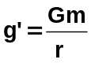 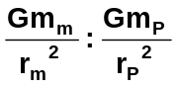 [1 mark]
G cancels as well as x 10²²
g _{(moon) :} g _{(Pluto]} 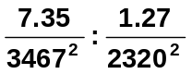 [1 mark]

6.11 x 10⁻⁷ : 2.36 x 10⁻⁷

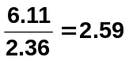
so moon has higher acceleration due to gravity by 2.59
[1 mark]

- One of Jupiter’s moons, Io, has a radius of 4.10 x 10⁵ kg. Io has a circular orbit and it takes 42.1 hours to orbit Jupiter.
  - What is Io’s orbital speed? (2 marks)

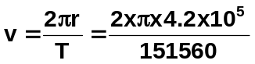t = 42.1 x 60 x 60
= 151560 s
[1 mark]
v = 1.74 x 10⁴ ms⁻¹ [1 mark]

  - What is the mass of the planet Jupiter? (3 marks)

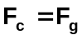 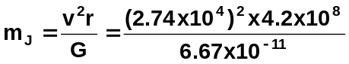 [2 marks]
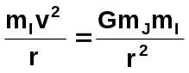 m_{J} = 1.91 x 10²⁷ kg [1 mark]
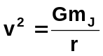

- Astronauts in orbit are considered to be “weightless”.
  - Why do you think the word “weightless” is in inverted commas? (2 marks)
This is not true weightlessness as the astronaut is in free fall around the Earth and so has gravity acting on him. [1 mark]
To be truly weightless the astronaut experiences no force on him such as in very deep space or if his net weight is zero. [1 mark]

  - Draw a free body diagram of an astronaut in a stable orbit above the Earth. (2 marks)

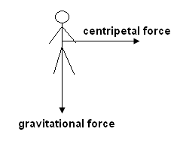

  - The astronaut is in a rocket which is in a stable orbit around the Earth. Which of the following statements is always true?
    - the period of the rocket must equal the period of the Earth’s rotation.
    - the Earth’s gravitational force does not affect the rocket.
    - the centripetal force acting on the rocket will be the gravitational force.
    - the net force on the rocket is zero answer: iii
[2 mark]

One of the above statements is sometimes correct. Which one and in what circumstance?
If the satellite is in a geostationary orbit then it would be correct, but satellites can be in a stationary orbit and not be geostationary. [1 mark]

